GCP Professional cloud architect 🡪

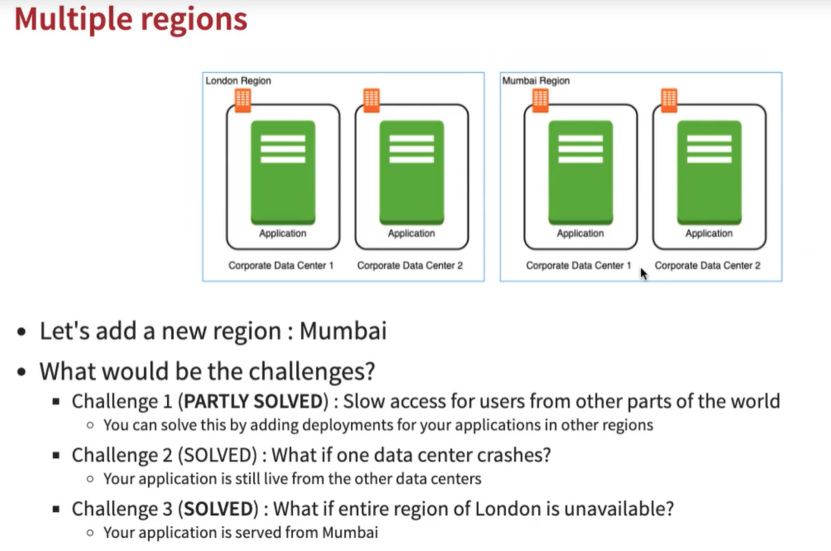

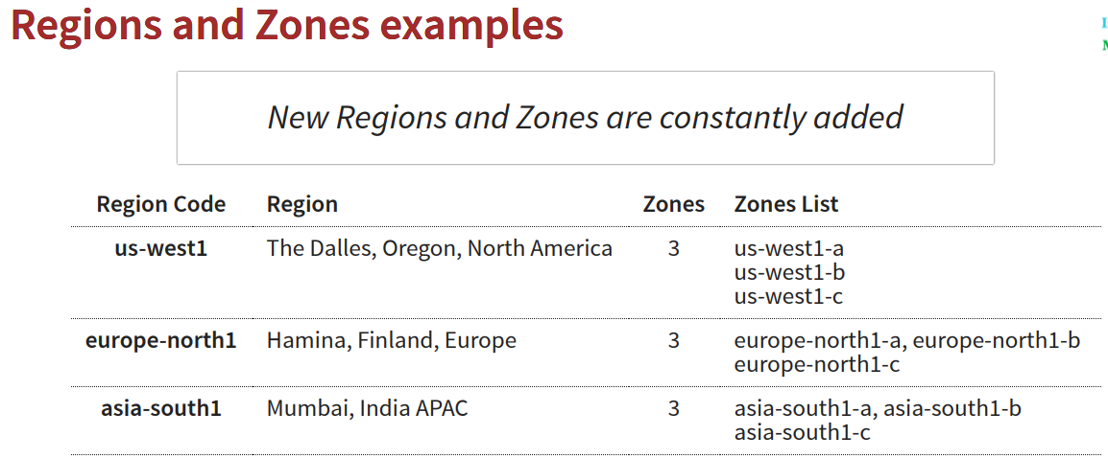

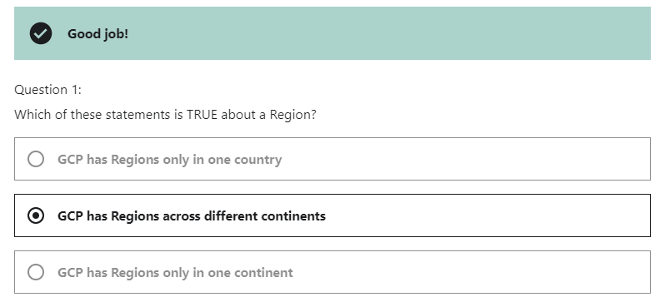

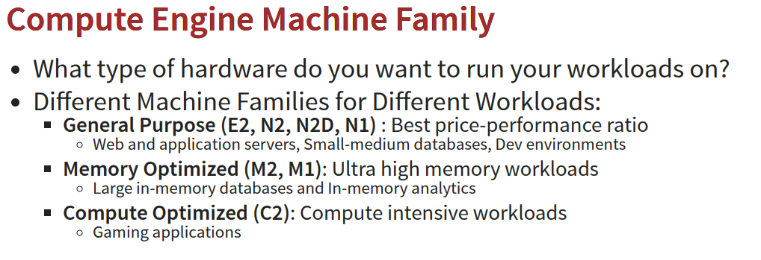

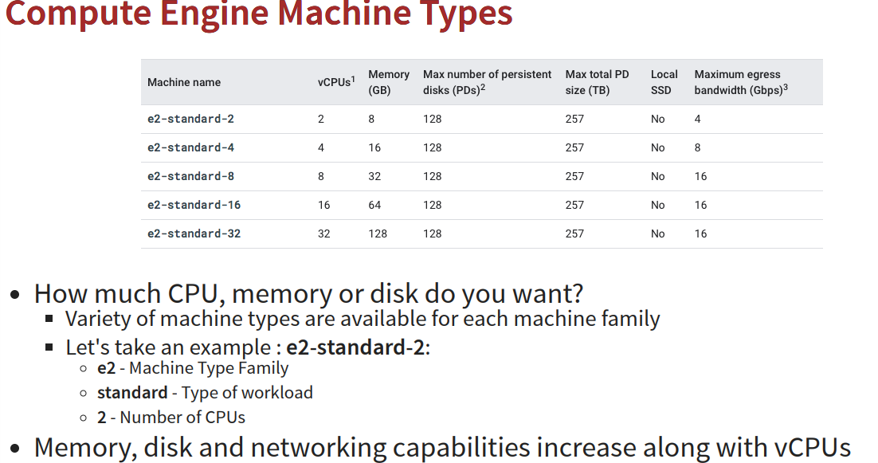

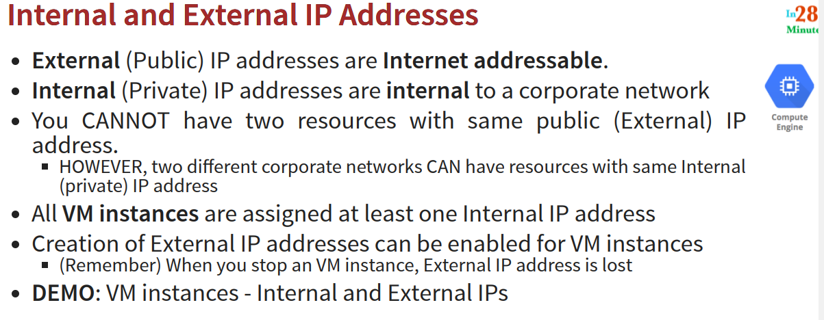

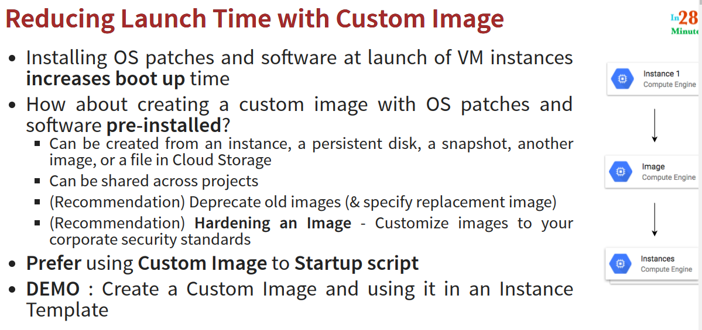

**Compute:**

Compute Engine🡪

* VM
* Instance template
* Sole Tenant node
* Machine images
* Storage :

Disks

Snapshots

images

* Instance Groups:

Instance groups

Health Checks

* VM manager

OS Patch management

OS configuration manag

**Instance template->** An instance template lets you describe a VM instance. You can then create groups of identical instances based on the template.

*We can define a standard type of machine cpu /RAM and bootable disk ubntu,window/linux here .*

Define machine type, image, labels, startup script and other properties

*Note :also we can use start up script ,*

*We don’t have charge to create Instance template.*

Launch VM instances using Instance templates.

*We can create a VM and Instance group with using this Template .*

We CANNOT be updated template .

To make a change, copy an existing template and modify it

*Custom Image :*

*Storage🡪Disks : we can here our disks details what we used in VM.*

*If We need the same disk (bootable) image for across our organisation as per standard ,we can “****create image****” option on this disk.*

*We can store this disk image in multi regionally or a region .*

***Note : we can not create image from running VM.we have to stop VM and make image***

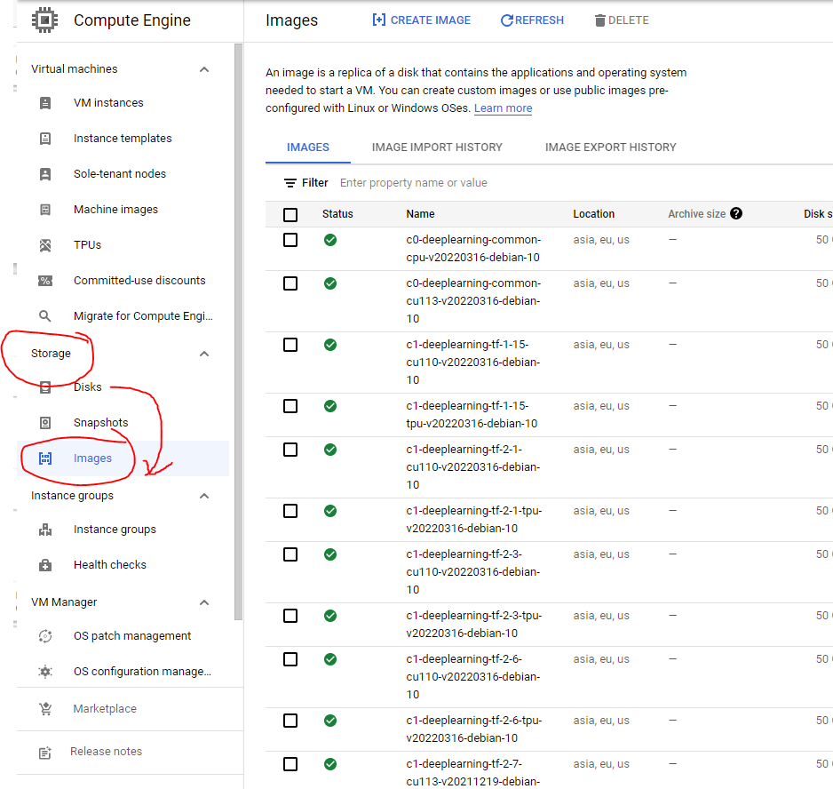

*Storage->images : we can see our image here from disk .and we can create a instance (VM) from this image from here ,also we can create instance template (go to instance template and we can choose boot disk 🡪 custom images as this image )*

*We have created a instance template with using custom image (bootable disk) + CPU + RAM as per Region required .*

*On this case we don’t need to setup /install any server/ s/w on this disk ,we can use directly this disk in VM.*

**Instance Groups**-> Instance groups let you organize VM instances or use them in a load-balancing backend service. You can group existing instances or create a group based on an instance template.

* Group of VM instances managed as a single entity.
* Manage group of similar VMs having similar lifecycle as ONE UNIT

New managed instance group (stateless)

Automatically manage groups of VMs that do stateless serving and batch processing.

New managed instance group (stateful)

Automatically manage groups of VMs that have **persistent data** or configurations (such as **databases** or legacy applications).

* Managed Instance Groups (MIG): Identical VMs created using an instance template.
  + - * + Features: Auto scaling, auto healing and managed releases.
        + Maintain certain number of instances If an instance crashes, MIG launches another instance .
        + Detect application failures using health checks (Self Healing).
        + Increase and decrease instances based on load (Auto Scaling) .
        + Add Load Balancer to distribute load. (*we can add a load balancer attached to your managed instance group to distribute load among the diff VM that are part of our MIG*)
        + Create instances in multiple zones (regional MIGs) [*and if you are creating regional MIG, you can distribute the instances across multiple zones this give us higher availability* .]

-Regional MIGs provide higher availability compared to zonal MIGs .

* + - * + Release new application versions without downtime .[*whenever I hve a new application version, I wud create a new instance of the instance template and I can upgrade from one instance of instanced Template to another instance of instanced Template without any downtime*].
        + Rolling updates: Release new version step by step (gradually). Update a percentage of instances to the new version at a time. [lets say if we need upgrade 2 instance at a time .. ]
        + Canary Deployment: Test new version with a group of instances before releasing it across all instances.[]

**Creating Managed Instance Group (MIG); Instance template is mandatory**

* Configure auto-scaling to automatically adjust number of instances based on load:

Minimum number of instances

Maximum number of instances

**Autoscaling metrics**: CPU Utilization target or Load Balancer Utilization target or Any other metric from Stack Driver.

**Cool-down period:** How long to wait before looking at auto scaling metrics again?

**Scale In Controls**: Prevent a sudden drop in no of VM instances Example: Don't scale in by more than 10% or 3 instances in 5 minutes.

**Autohealing**: Configure a Health check with Initial delay (How long should you wait for your app to initialize before running a health check?)

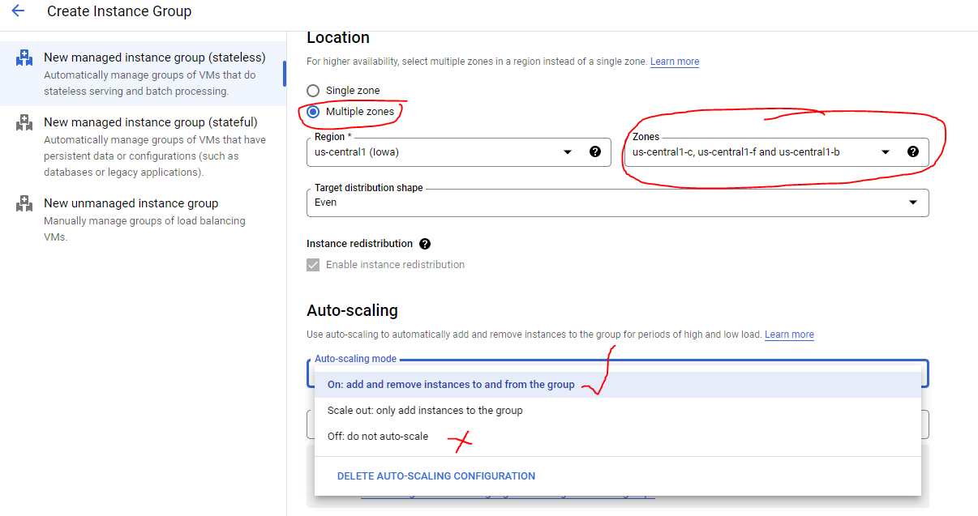

MIG can decide when to auto scale 🡪according to this metrics

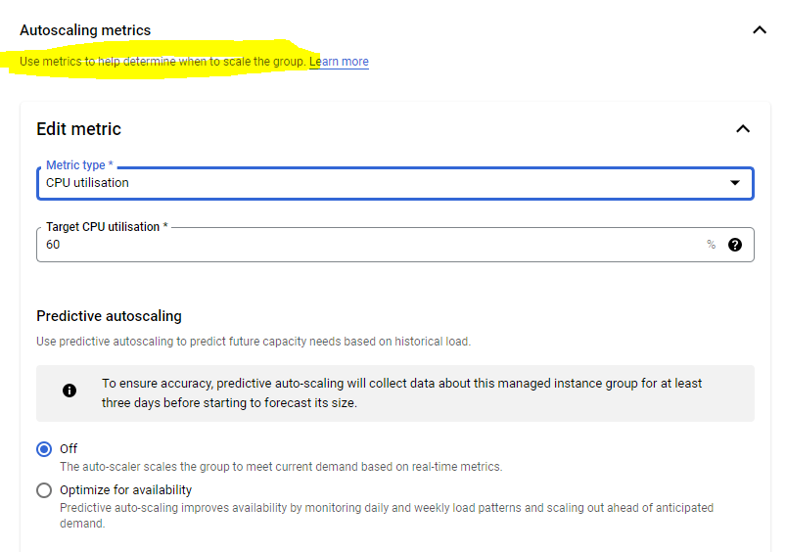

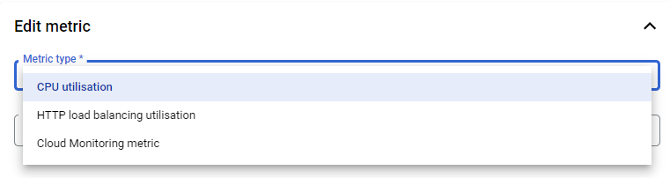

##### New feature : **Predictive autoscaling**

Use predictive autoscaling to predict future capacity needs based on historical load.

**Autoscaling schedules:** We have another feature to auto scale based on a schedule . you can say at this time , I would want to increase the number of instances of this specific things .and at a later point of time I would want to decrease the number of instances .Autoscale the group on a regularly scheduled basis.

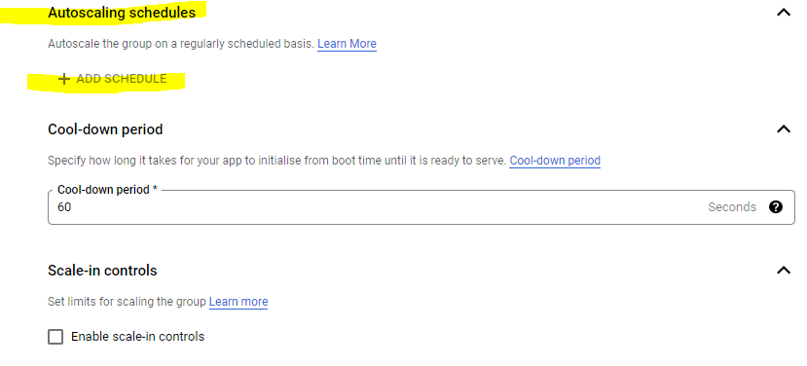

**Cool down period**:🡪 Specify how long it takes for your app to initialize from boot time until it is ready to serve.

how long do you want to wait before yuou would look at the metrics again ?

**Scale in controls** , we can scale in 10 instances down out of 100 vms

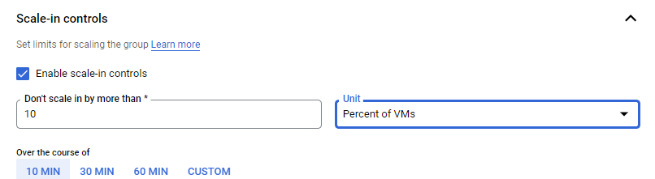

I don’t want to scale in by more than 10 percent of VMs in a 10 mins period .

Instead of directly going in from 100 systemns to 10 instances ,to first go down to 90 , then 80 ……

**Scale in** means redice no. of VM instacnes when loard decrease.

**Scale out** : increase no of VM when load increase.

## Auto-healing

Autohealing recreates VM instances if your application cannot be reached by the health check.

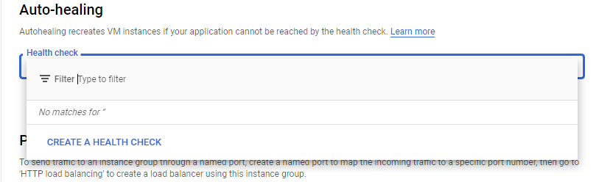

Compute Engine will recreate VM instances only when they're not running.

Health Check :-> A health check determines whether a VM instance is healthy by sending requests to the instance. An instance is considered healthy if it returns consecutive responses within a specified time. Health checks are used for load balancing and auto-scaling managed instance groups

Remember to change the protocal to HTTP,we are using HTTP URL to access the application ,which is deployed on our VM.

*Define how health is determined: how often to check, how long to wait for a response and how many successful or failed attempts are decisive*

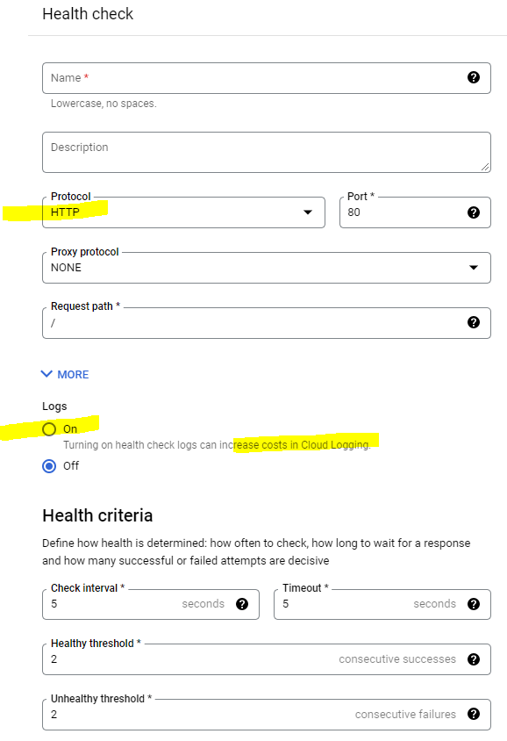

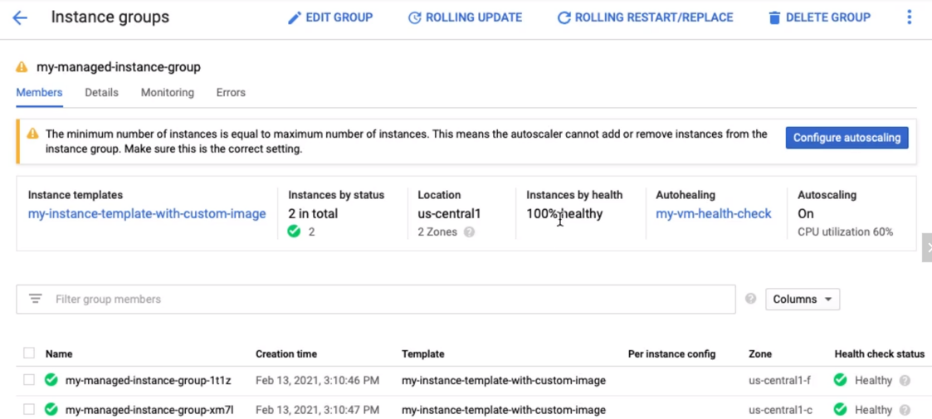

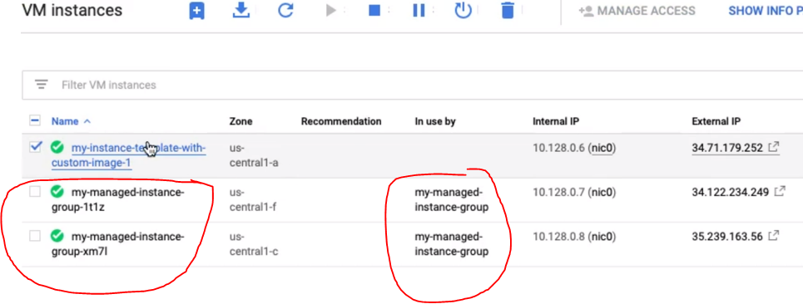

**Updating a Managed Instance Group (MIG)**

**Rolling update** - Gradual update of instances in an instance group to the new instance template .( *Lets have a one version of the instance template , and I would want to upgrade to the new version of the instant template.The ealier version of the template might be refering to an old verion of the application.And new version of the instance template is refering to the new version of the application.On this situation ,we need to switch new from old version of application.-> First we need to specify new template (optionally we can also specify a template for canary testing* . We want to update 2 instances from 10 instances .2 instances first and 2 instances next ,so we are will updating in a group of 2 instances each .**Canary testing approach** :🡪 2 instacnes all tested ,you would roll out at once to the rmaining 8 instances .You can do both canary testing and gradual roll out an update of a managed instance group .

Specify how you want the update to be done: When should the update happen?-->

1 **proactive** (start update immediatly)

2 **opportunistic** (update later ))

How should the update happen? **Maximum surge**: How many instances are added at any point in time? (I would want to add a max of two instances at any point in time ). Exp 12 instances that would be running at any point in time.

**Maximum unavailable:** How many instances can be offline during the update?(while the update is going on ,how many instance can ne offline ? , while the update is going on let s say 2 instance can be offline ,then those 2 instances can be updated with new version ,remaining 8 instances will be serving traffic ).

Reference : Specify new template: (OPTIONAL) Specify a template for canary testing Specify how you want the update to be done: When should the update happen? Start the update immediately (Proactive) or when instance group is resized later(Opportunistic) How should the update happen? Maximum surge: How many instances are added at any point in time? Maximum unavailable: How many instances can be offline during the update?

**Rolling Restart/replace**: Gradual restart or replace of all instances in the group .

No change in template BUT replace/restart existing VMs .

Configure Maximum surge, Maximum unavailable and What you want to do? (Restart/Replace).

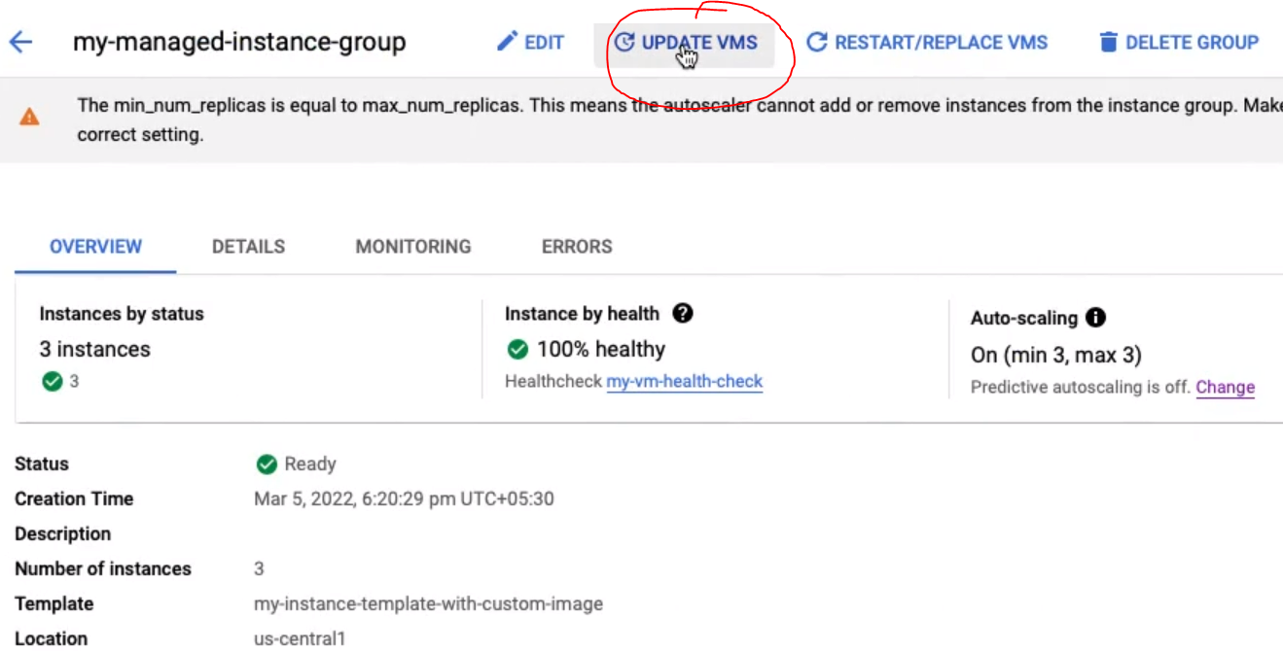

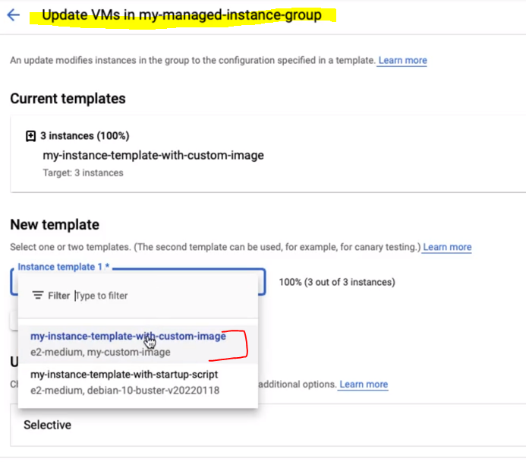

If we don’t want to change instance template immediately ,we can “add a second template “ and choose new desire template with size 1 .once I tested , I can then increase the no of instances for that specifc template .

On rolling update ,we are actually changing the template and we also have the option to look and re testing .

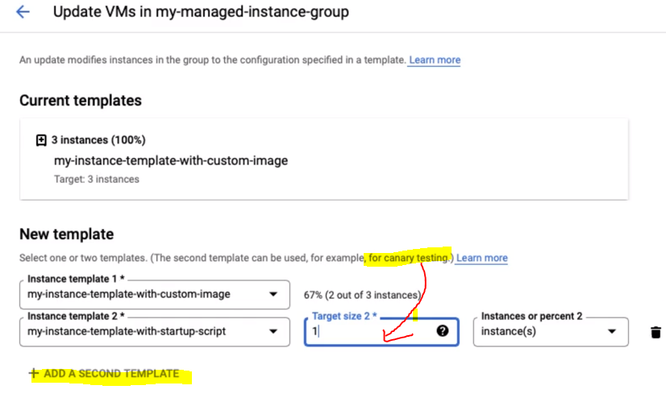

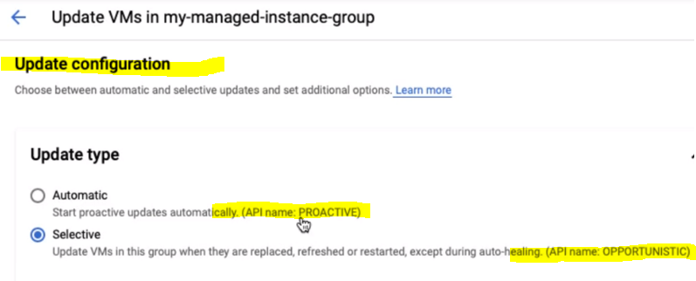

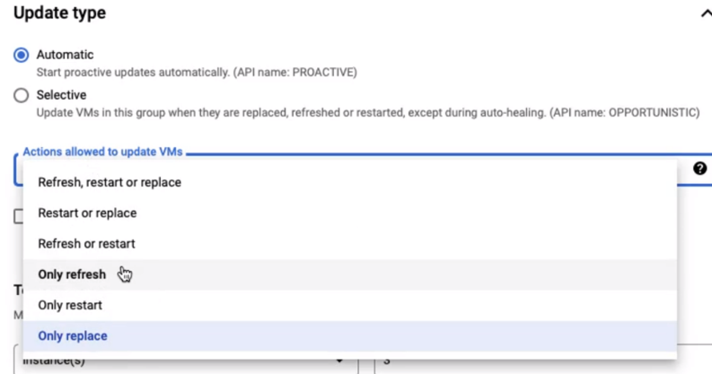

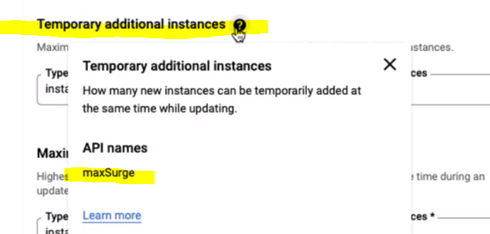

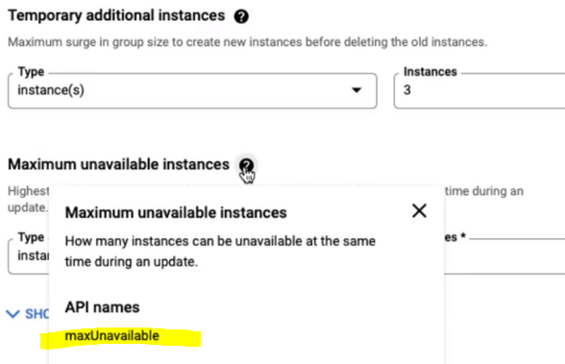

EDIT VMS🡪an update modifies instances in the grp to the configure specified in a template .

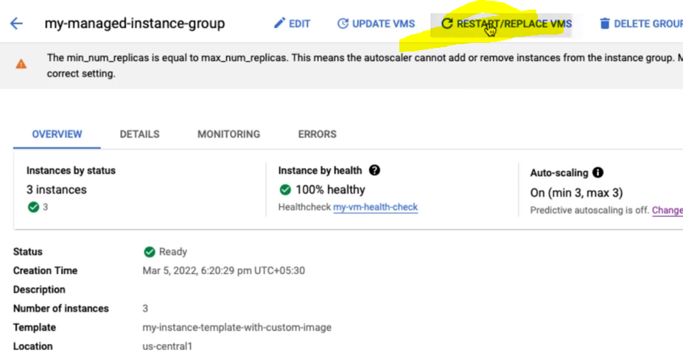

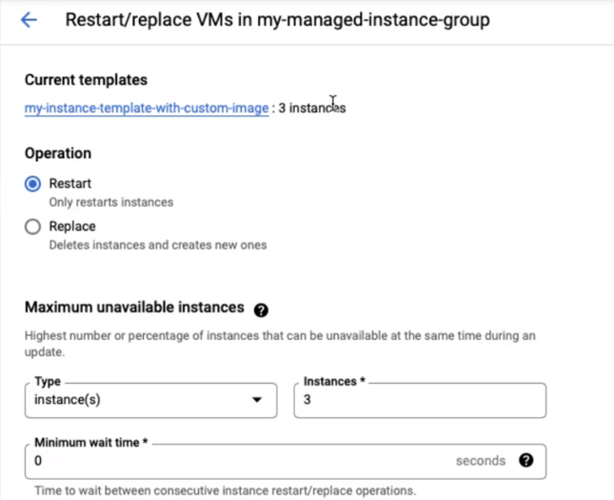

Unmanaged : Different configuration for VMs in same group: Does NOT offer auto scaling, auto healing & other services NOT Recommended unless you need different kinds of VMs

Compute🡪 Kubernetes Engine->

**VM manager :** I have 1000s of VM and I want to automate OS patch management, OS inventory management and OS configuration management ((manage software installed)

NETWORK:

* VPC NETWORK

VPC Networks

External IP Addresses

Bring ur IP

Firewall

Routers

VPC Network Peering

Shared VPC

Serverless VPC access

Packate monistoring

* NETWORK SERVICES

Load balancing

Cloud DNS

Server Directory

Cloud NAT

* Hybrid Connectivity
* Network Service tier
* Network Security
* Network intelligence

IP🡪

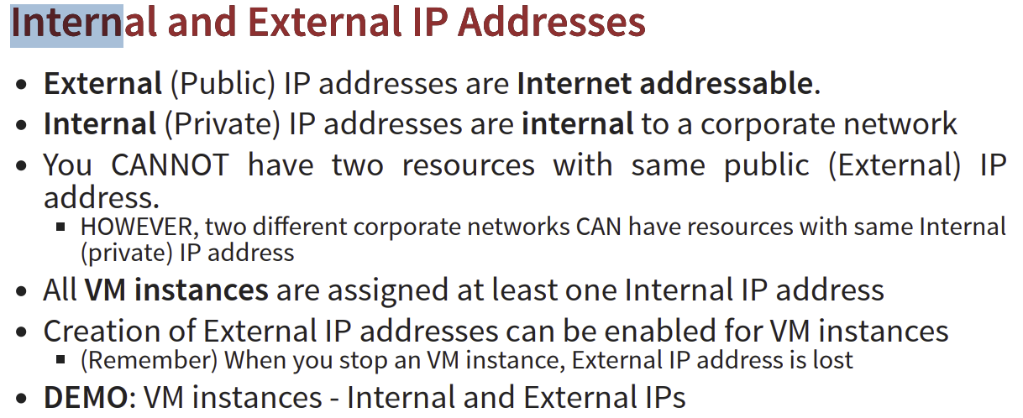

**VPC🡪External IP Addresses:->** If you create any VM the external IP creates and you can find the more details of the external ip in VPC🡪External IP Addresses section .

Also we can Reserve **Statis IP** addresses on this section.ipv4/ipv6 , regional or global statis address

Caution : select the same region as that of your VM (static address should be in the same region as ur VM)

Also we can assign this static IP to any VM from here with using CHANGE Button right hand side .

We can create image from storage🡪disk

The disk associates with Running VM and if we need to create an image from disk so we need to stop first .

And we can create VM from image with choosing boot disk 🡪 select image and also we can create instance templates from using this image as well .

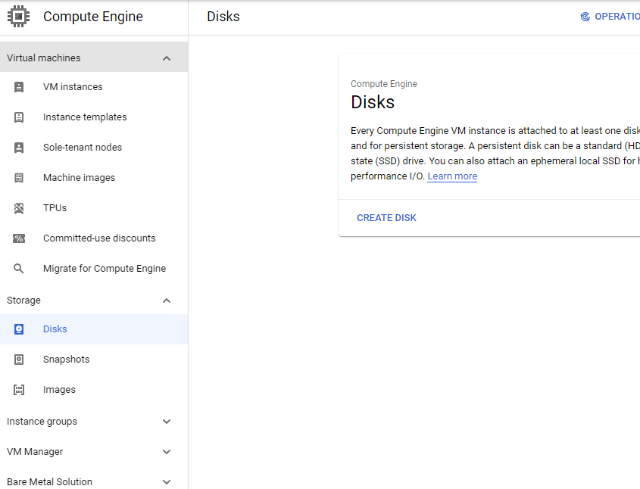

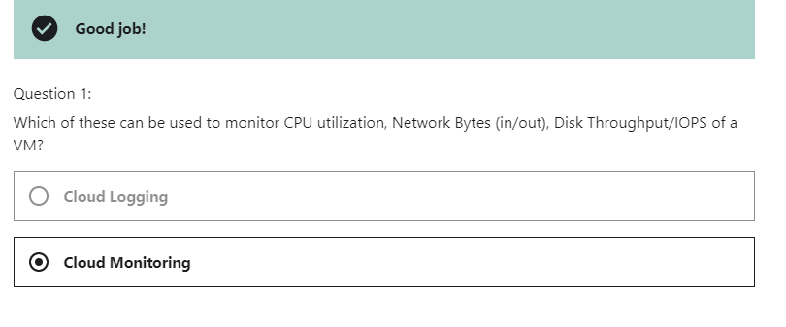

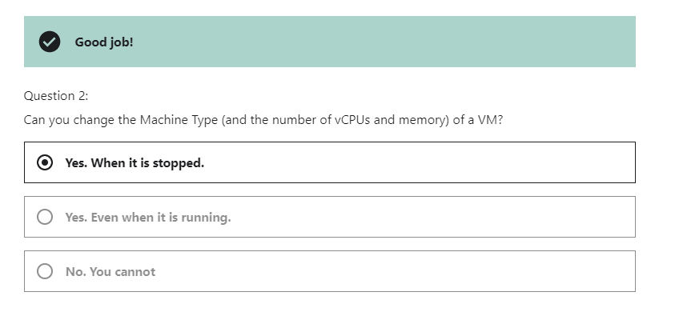

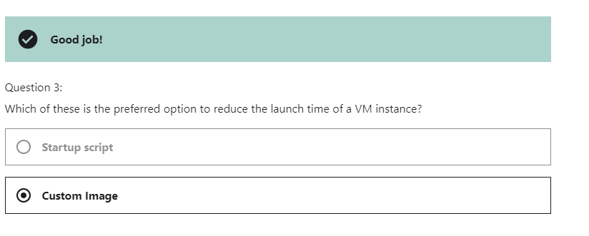

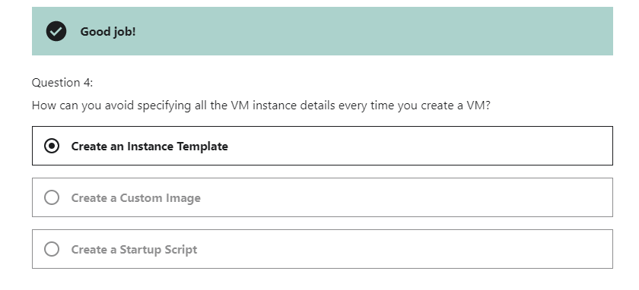

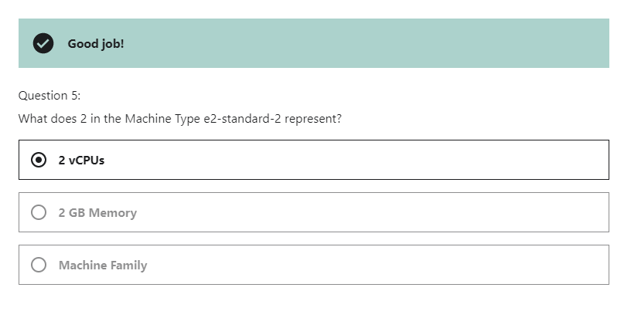

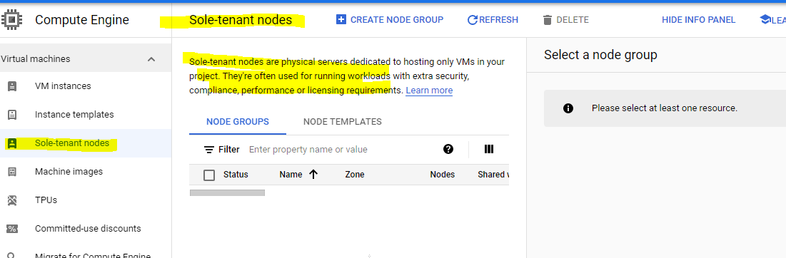

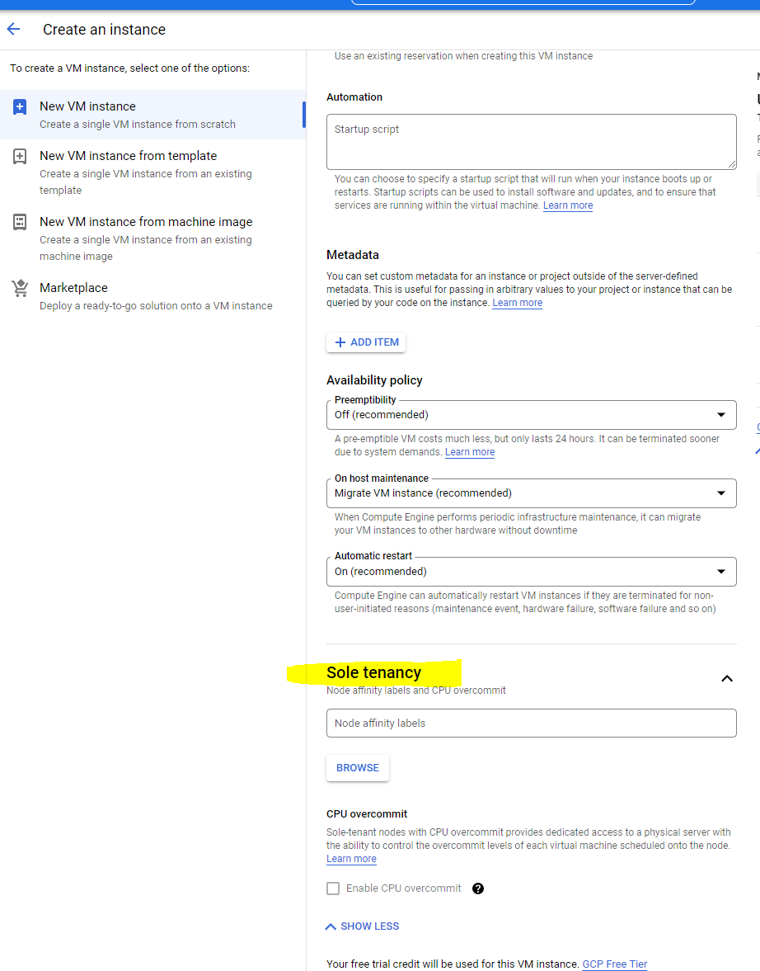

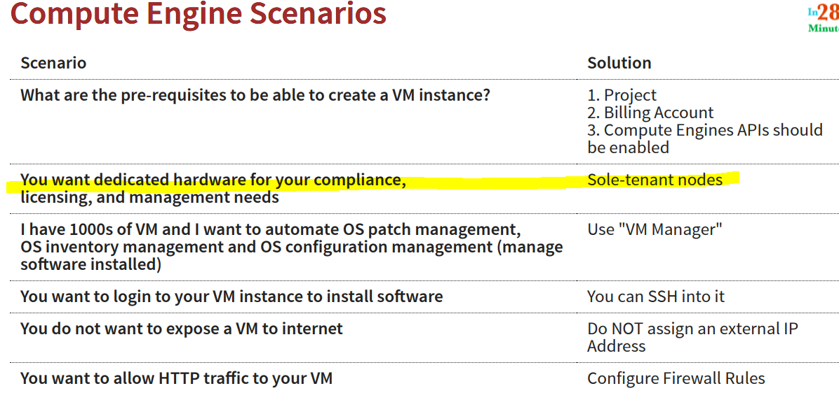

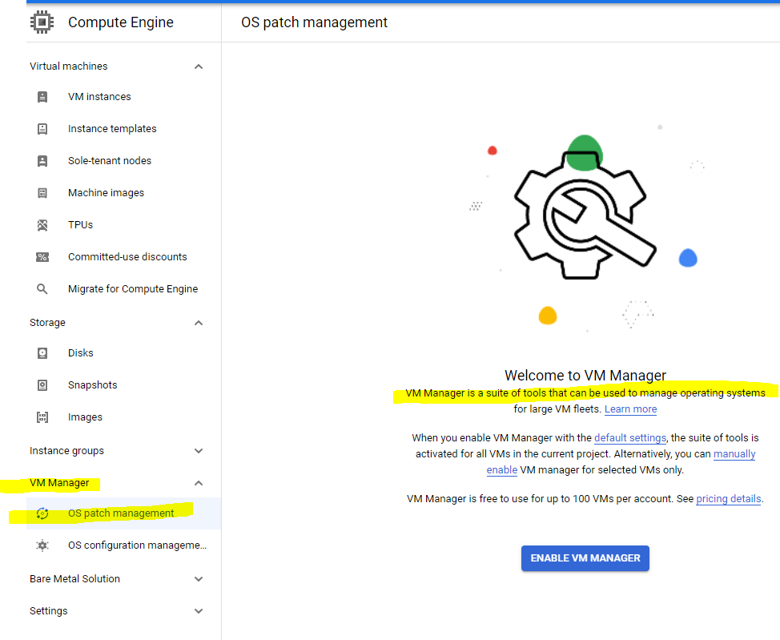

Instance groups

Instance groups let you organise VM instances or use them in a load-balancing backend service. You can group existing instances or create a group based on an instance templat

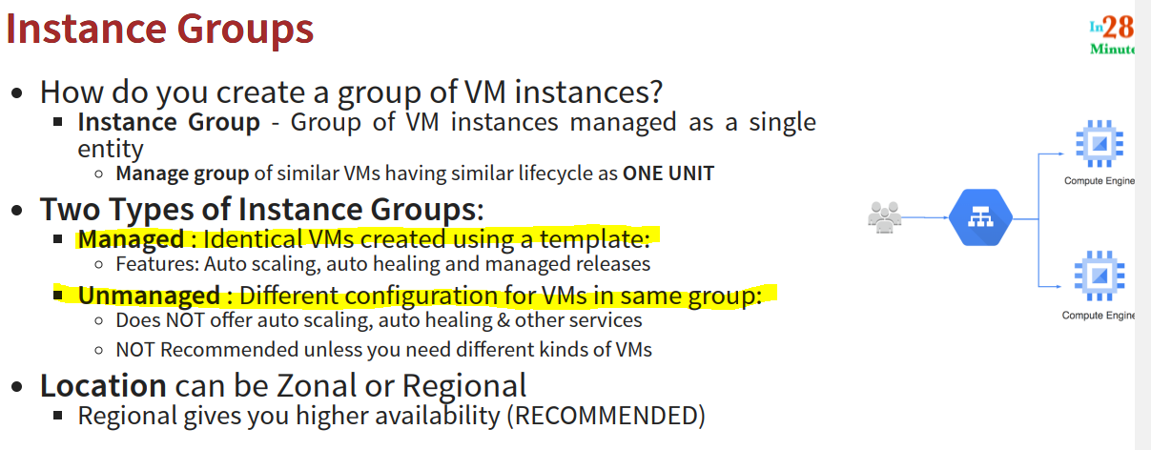

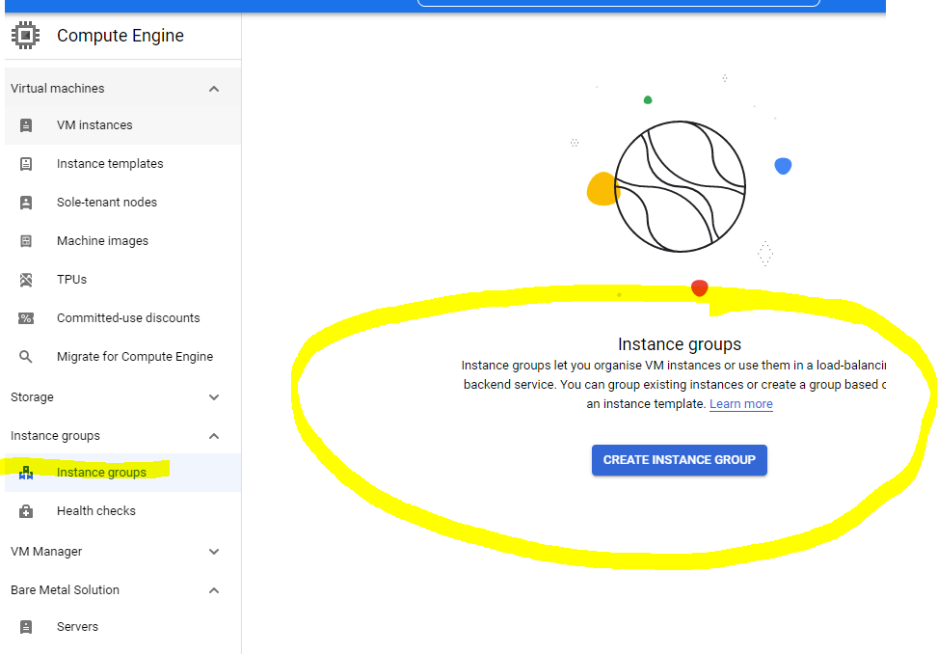

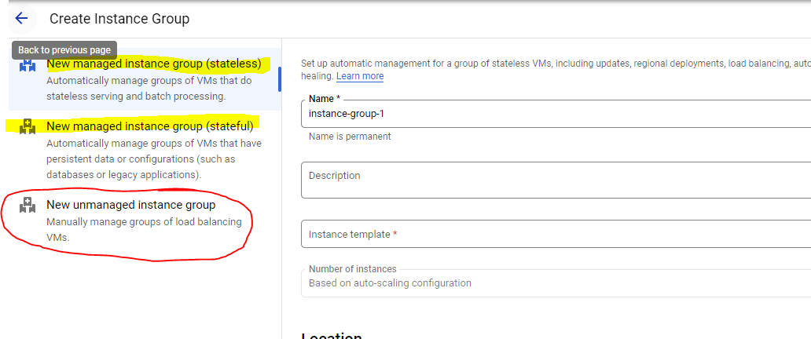

New managed instance group (stateless)

Automatically manage groups of VMs that do stateless serving and batch processing.

New managed instance group (stateful)

Automatically manage groups of VMs that have **persistent data** or configurations (such as **databases** or legacy applications).

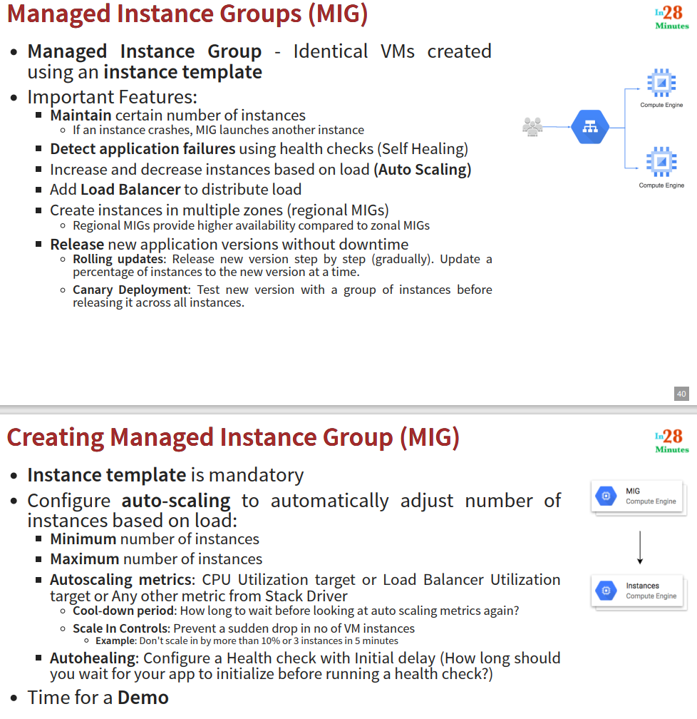

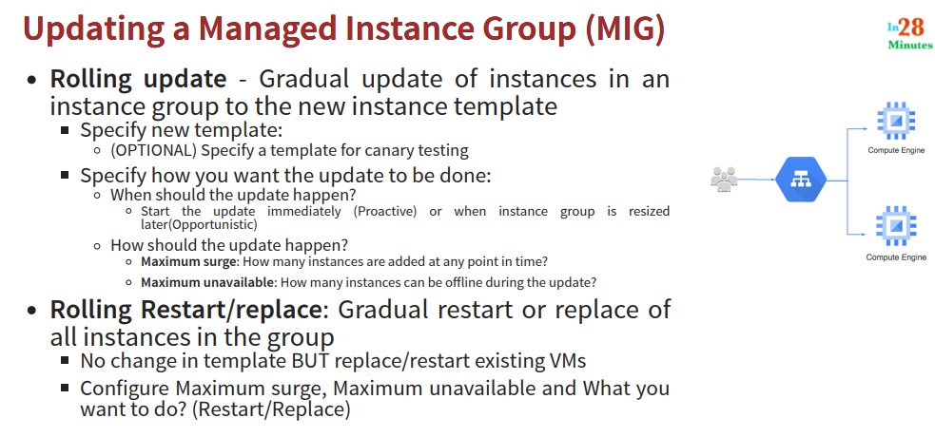

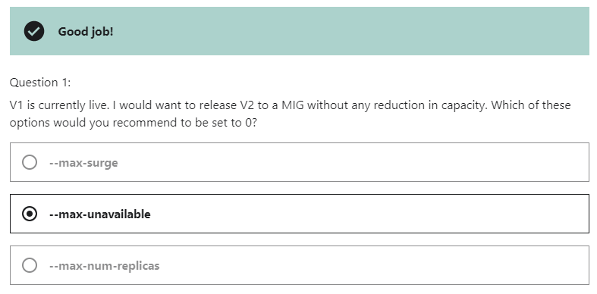

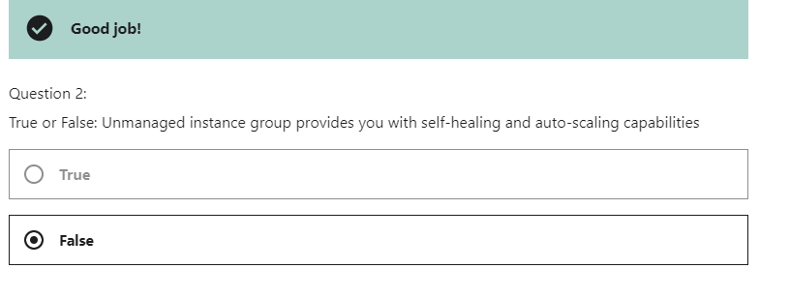

Manage IG🡪 Auto -scaling : we **can off ,no auto scaling** and we can **ON auto scaling (only add or remove instances to and from grpup)** and **scale out (only add instances to the grp).**

**Cool down period for Metric**

**Scale in controls , we can scale in 10 instances down out of 100 vms**

**Scale in means redice no. of VM instacnes when loard decrease.**

**Scale out : increase no of VM when load increase.**

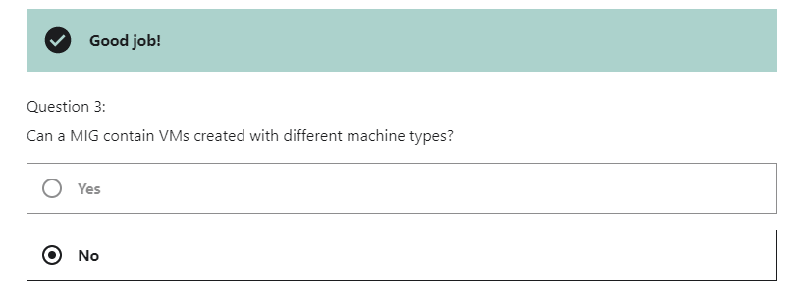

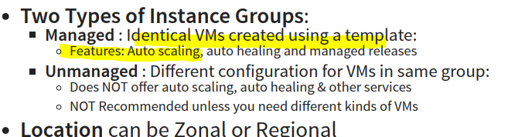

Manage I Group🡪 Location would be multiple Zone or single zone

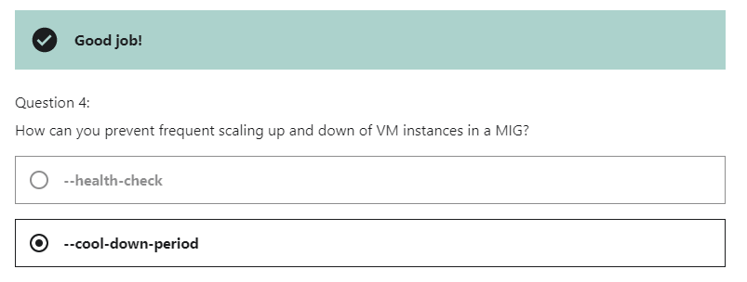

Health check🡪

Autoscaling schedules :->

Cool down period :-> specify how long it takes for ur app to initialize from boot time until it is ready to serve .

**Cloud load Balancing🡪**

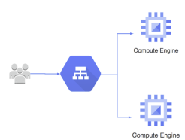

Distributes user traffic across instances of an application in single region or multiple regions Fully distributed, software defined managed service .

**Health check** - Route to healthy instances

Recover from failures.

**Auto Scaling -**

**Global load balancing with single anycast IP**

Also supports internal load balancing

Enables:

* High Availability
* Auto Scaling
* Resiliency

**Network services 🡪 Load balancing** , Load balancers distribute incoming network traffic across multiple VM instances to help your application scale.

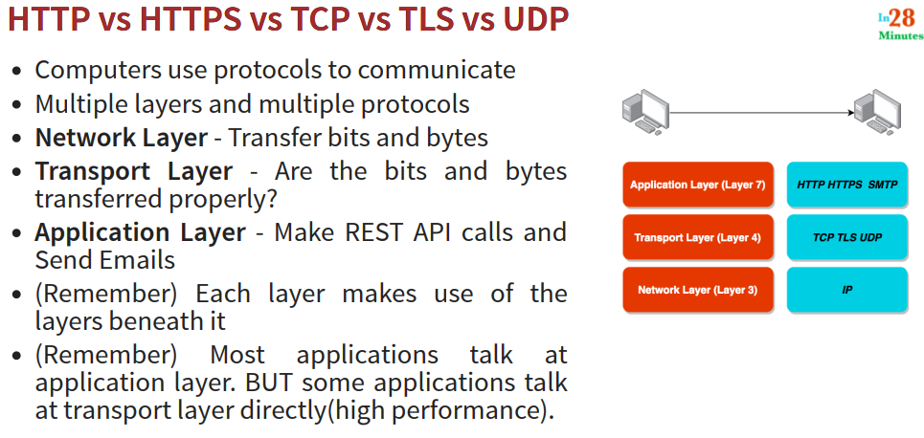

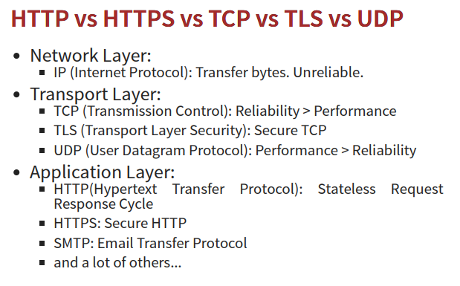

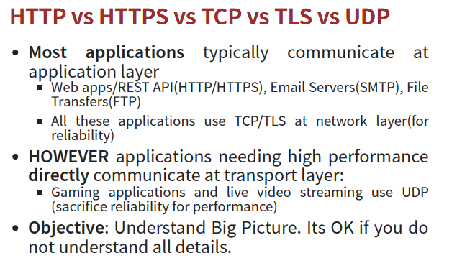

**UDP load balancing**

Layer 4 load balancing for applications that rely on UDP protocol

* Internet-facing or internal
* Single-region

## TCP load balancing

Layer 4 load balancing or proxy for applications that rely on TCP/SSL protocol[L](https://developers.google.com/compute/docs/load-balancing/network/?hl=en_GB)

* internet-facing or internal
* **Single- or multi-region**

## HTTP(S) load balancing

Layer 7 load balancing for HTTP and HTTPS applications

* Internet-facing or internal
* Single- or multi-region

**Load Balancing 🡪**

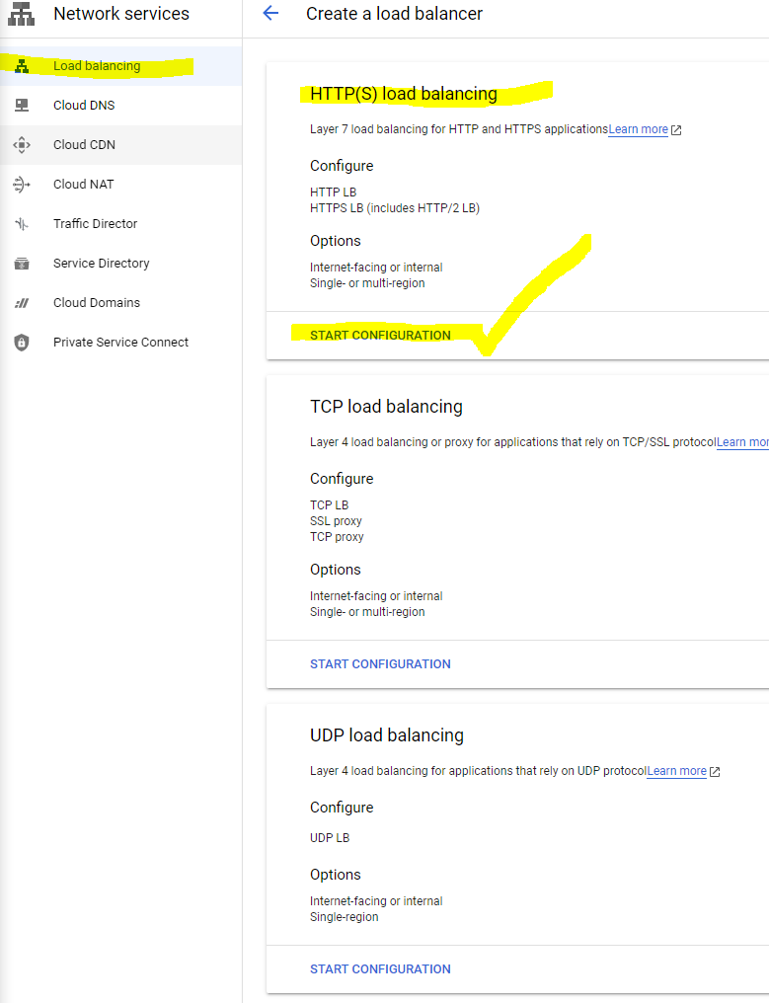

HTTPS Load balacing 🡪

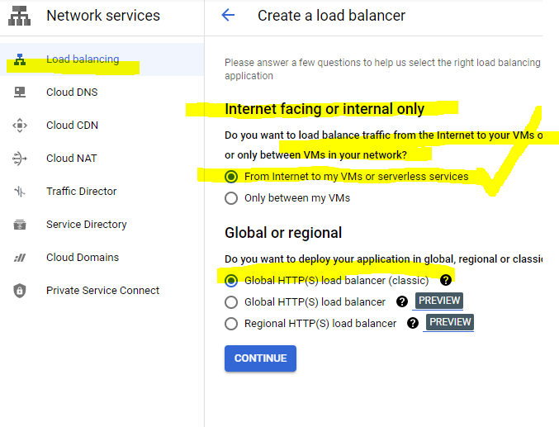

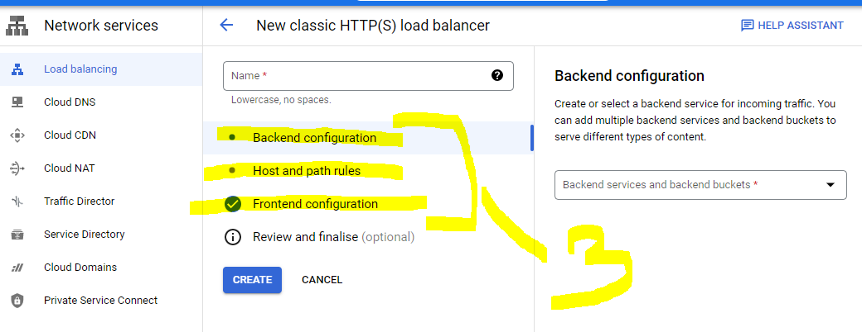

Backend 🡪 Managed instance group

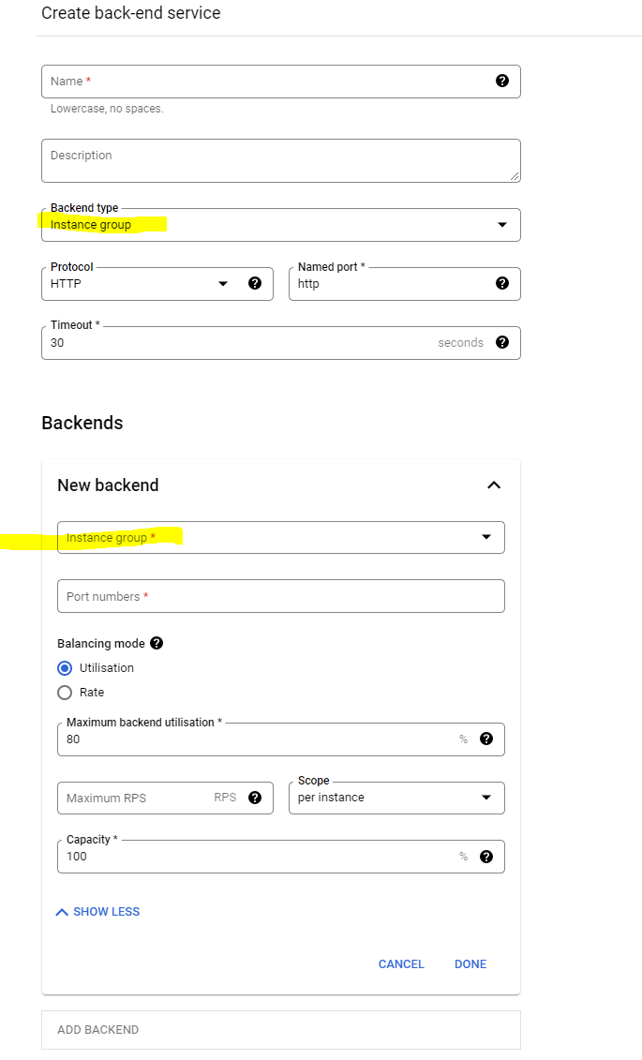

We can add more Backend (managed instance groups )🡪

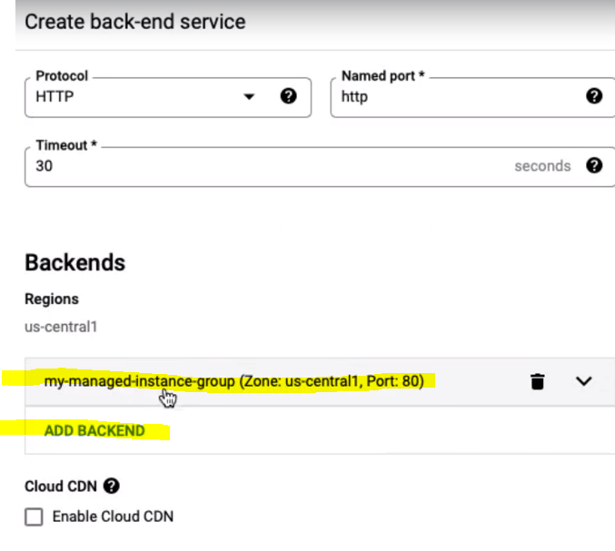

Add healthCheck 🡪

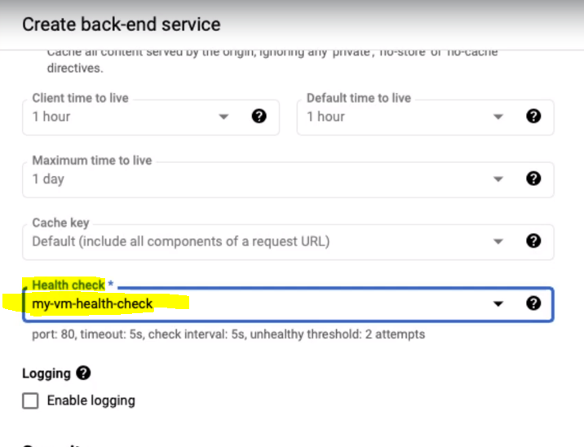

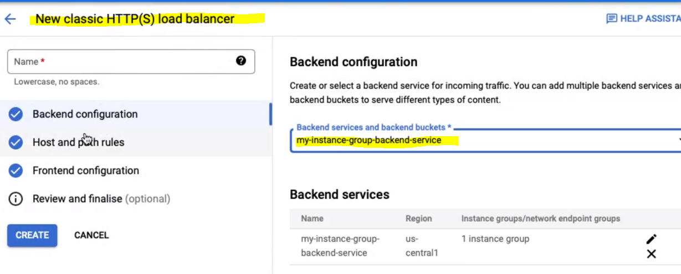

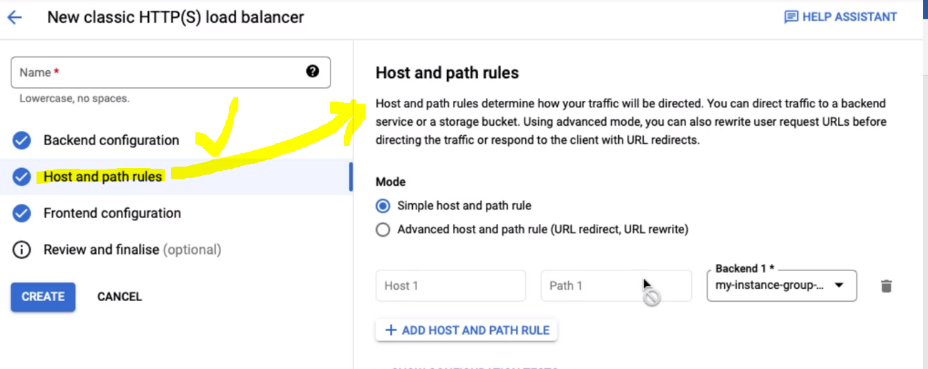

If we have microservgices ,we can configure multiple backend 🡪

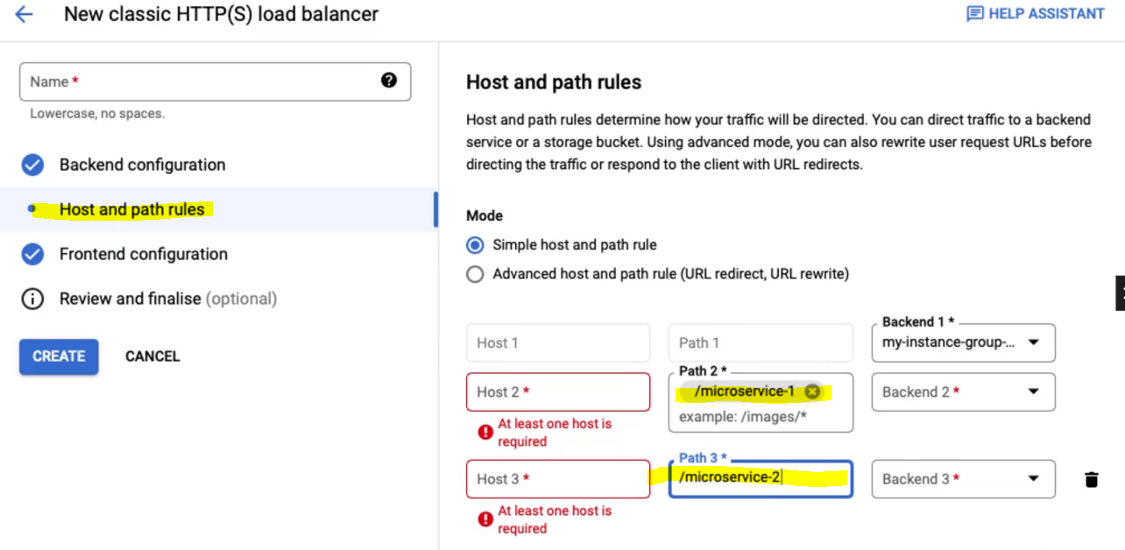

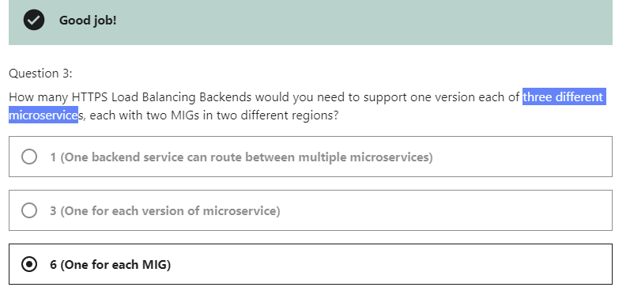

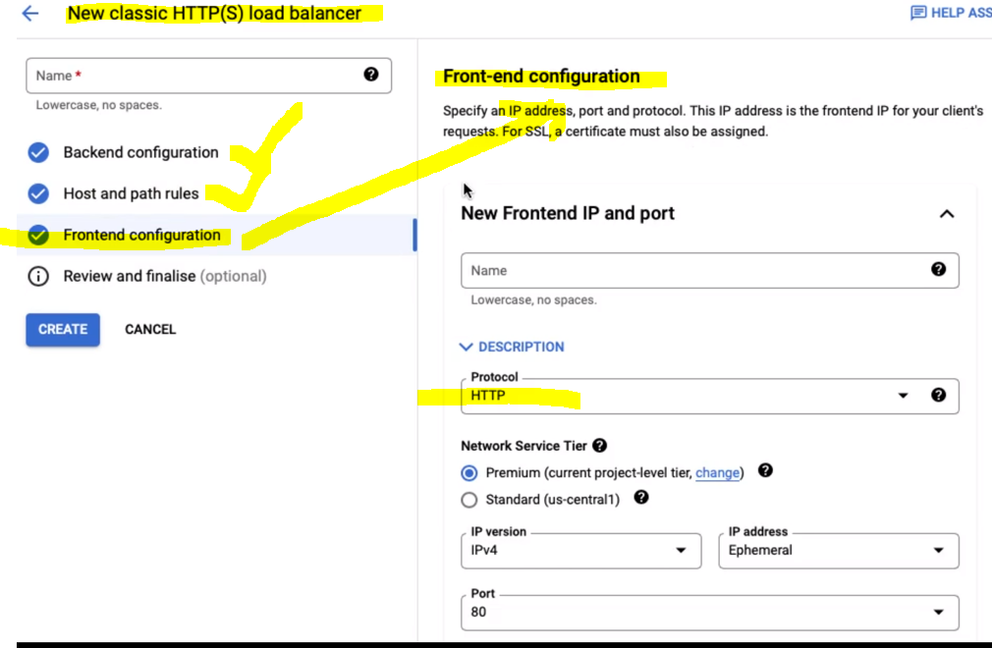

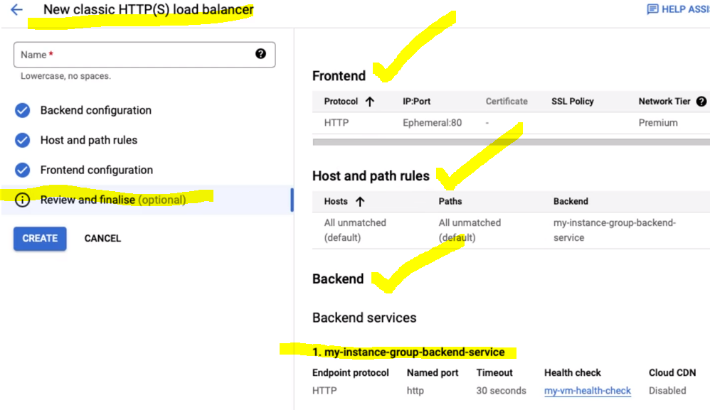

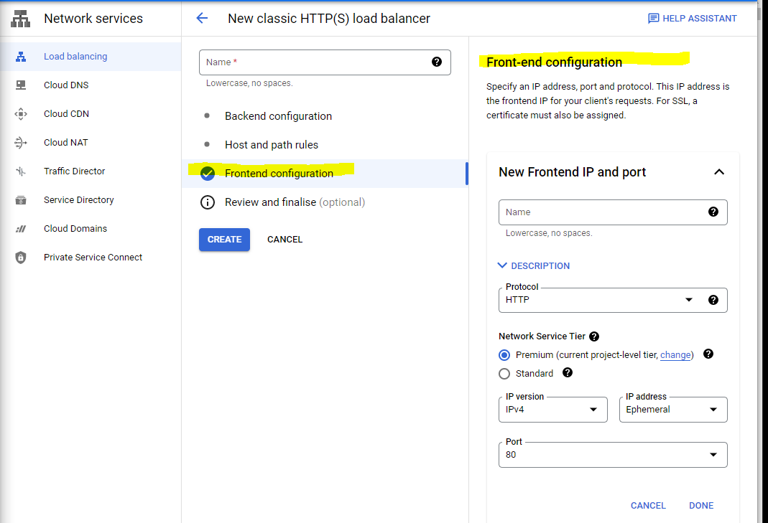

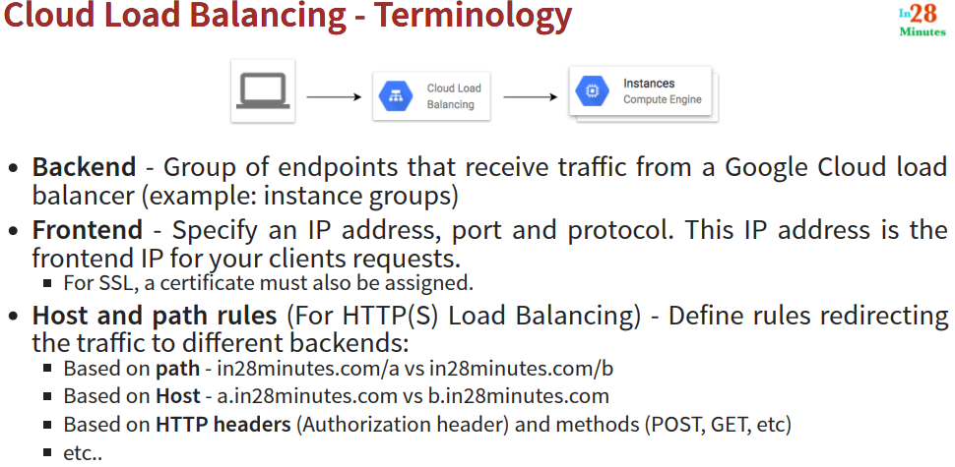

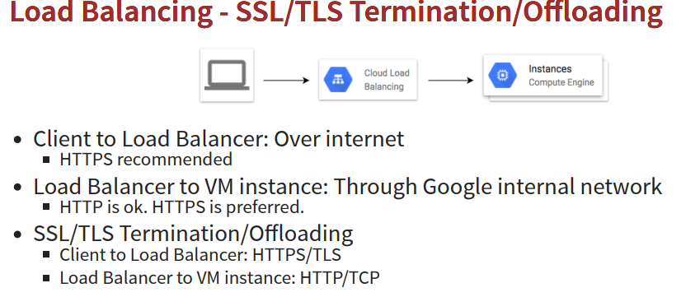

**Load Balancing - SSL/TLS Termination/Offloading🡪**

Network layer (3)-- IP

Transport layer 4 🡪 TCP,TLS,UDP

Application layer 7 🡪HTTP https ,smtp

Backend : instance group

Frontend : IP address ,port ,protocal ,this IP address is the frontend ip for your client request .(SSL assign to cloud balancer).

Host/path rules: (for https load balancing) – define rules redirecting the traffic to diff backend.

Load balancing is SSL termination or SSL offloading (TLS termination or TLS offloading ).

If we are using layer 7 ,then we are doing SSL termination or SSL offloading .

If we are using layer 4 ,we are using Security ,then we are TLS termination / TLS offloading.

Lets assume a scenario where you are exposing an application on the internet ,the **client to the load balancer going over internet** **and for this Traffic HTTPS is recommended and we need to be me more secure by assigning a SSL certificate to your cloud load balancer .**

**Cloud balancer to VM (CE)** going through the google internal network via HTTP/HTTPS and that’s’s the reason why SSL termination or offloading important . if we are using SSL termination ,that basically we are communicating only application **layer 7** **using HTTPS** ,

then **Client to load balancer** communication happens using HTTPS

and the **load balancer to the VM** Communication happen using HTTP, So SSL or the secure part of communication is being terminated at the load balancer and that’s’ the reason why this is called SSL termination or SSL offloading,

**if you are using layer 4 communication this is called TLS termination or offloading** and b/w **client and load balancer** TSL used and b/w the **load balancer and vm** instance we have unsecured communication which through TCP ,which is the advantage of going for SSL termination is that you are **reducing** the load on the instances .

Instances don’t rally need to worry about HTTPs or TLS . else they can directly handles the request

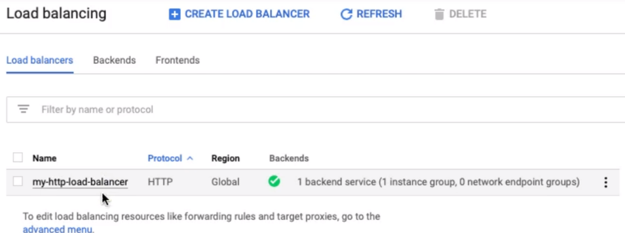

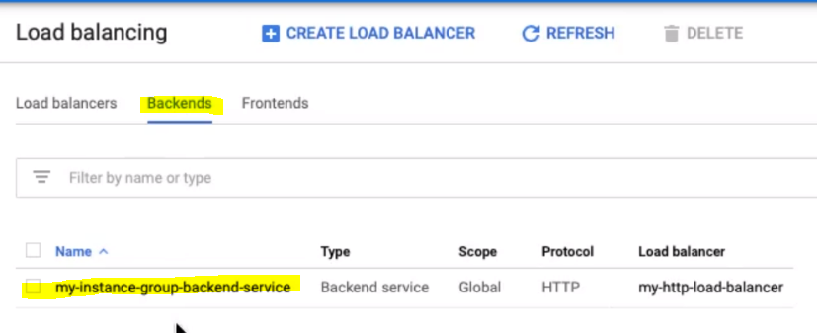

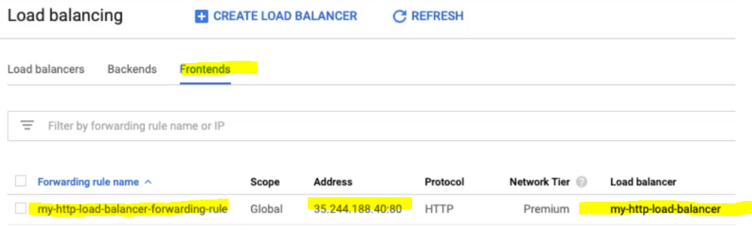

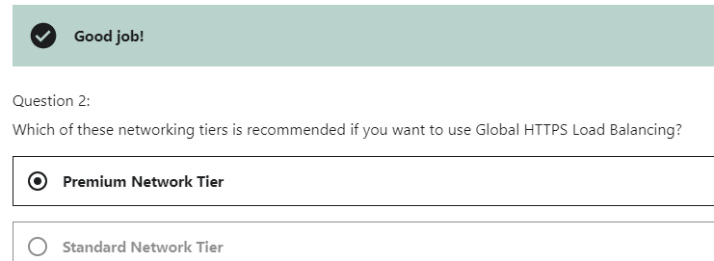

My https load balancer 🡪

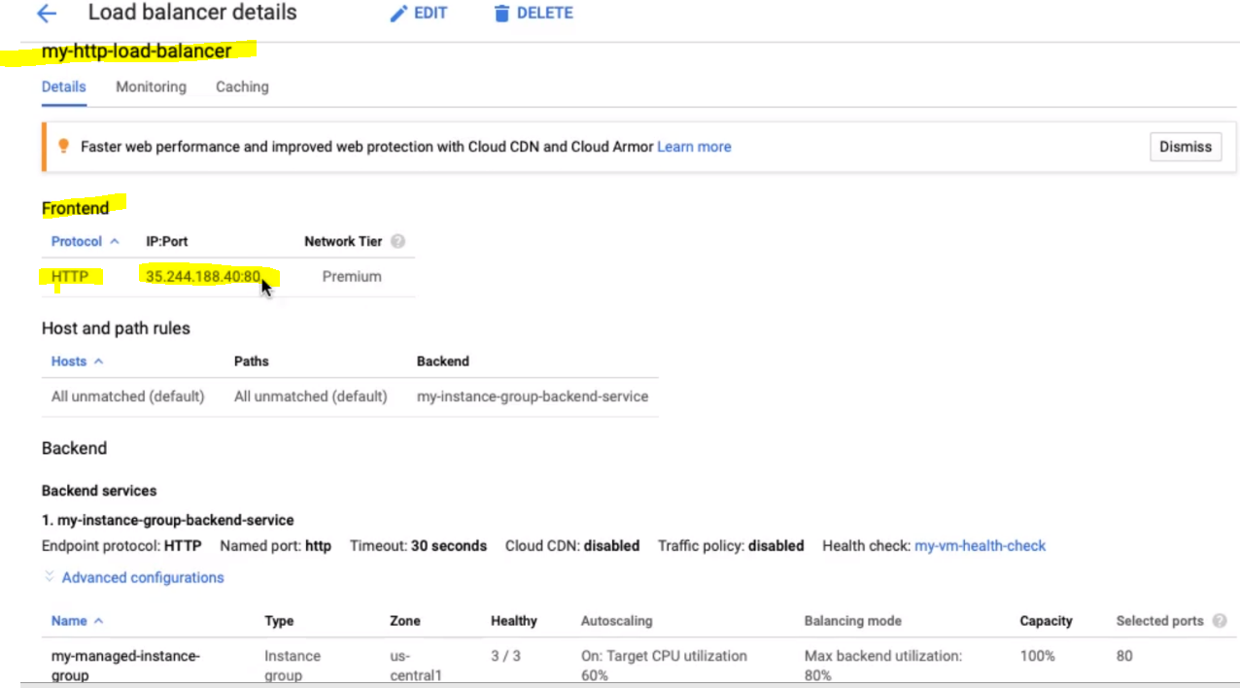

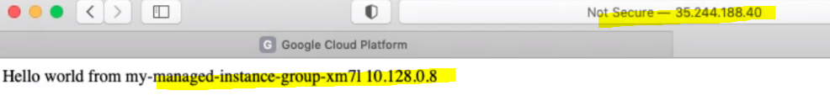





Load balancer is switching diff Instances

How to choose Load balancer 🡪

For traffic is Internal to a network , then the important is what kind of traffic :

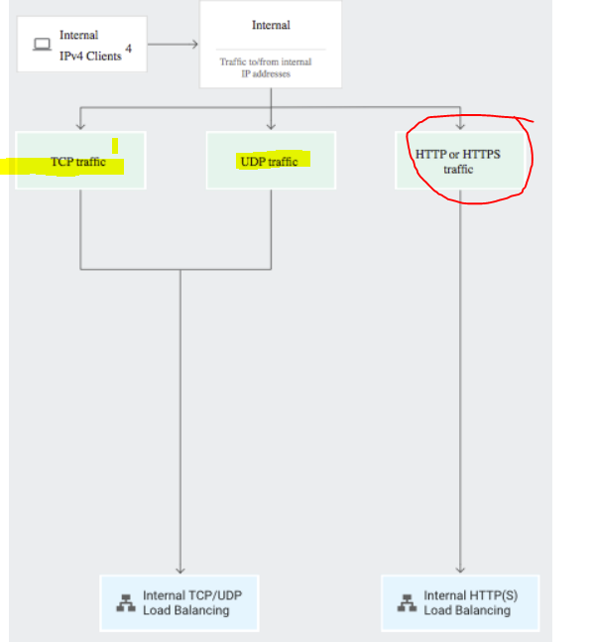

Traffic coming from internet :

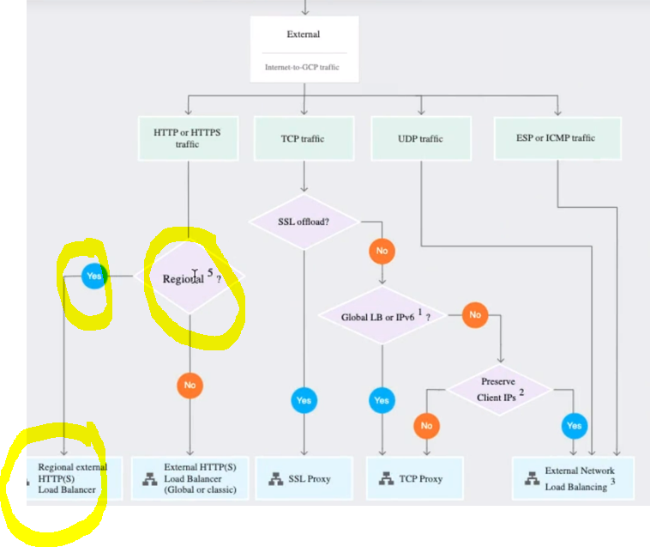

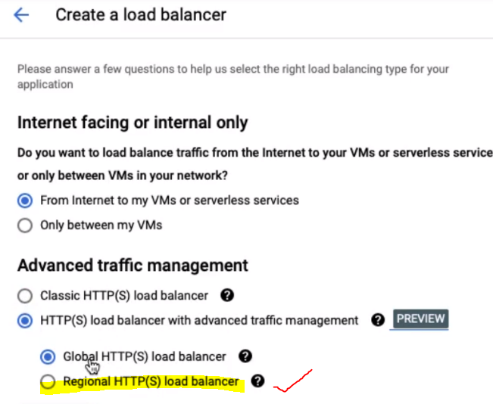

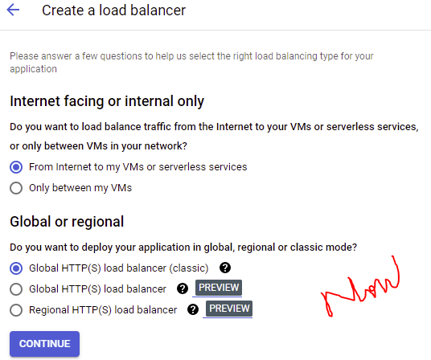

ON TCP TrafFic :🡪

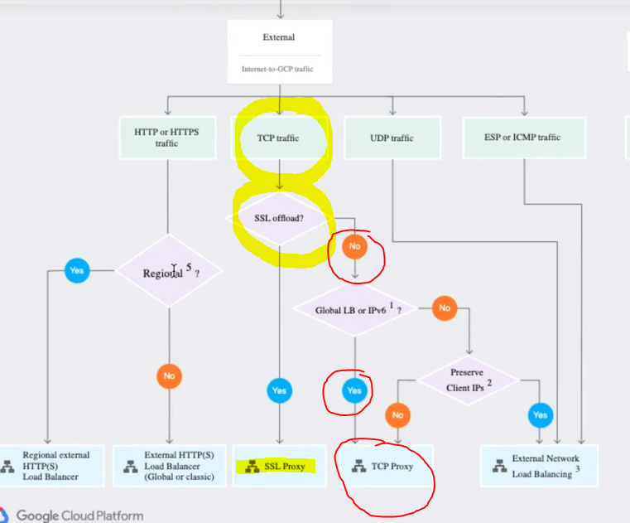

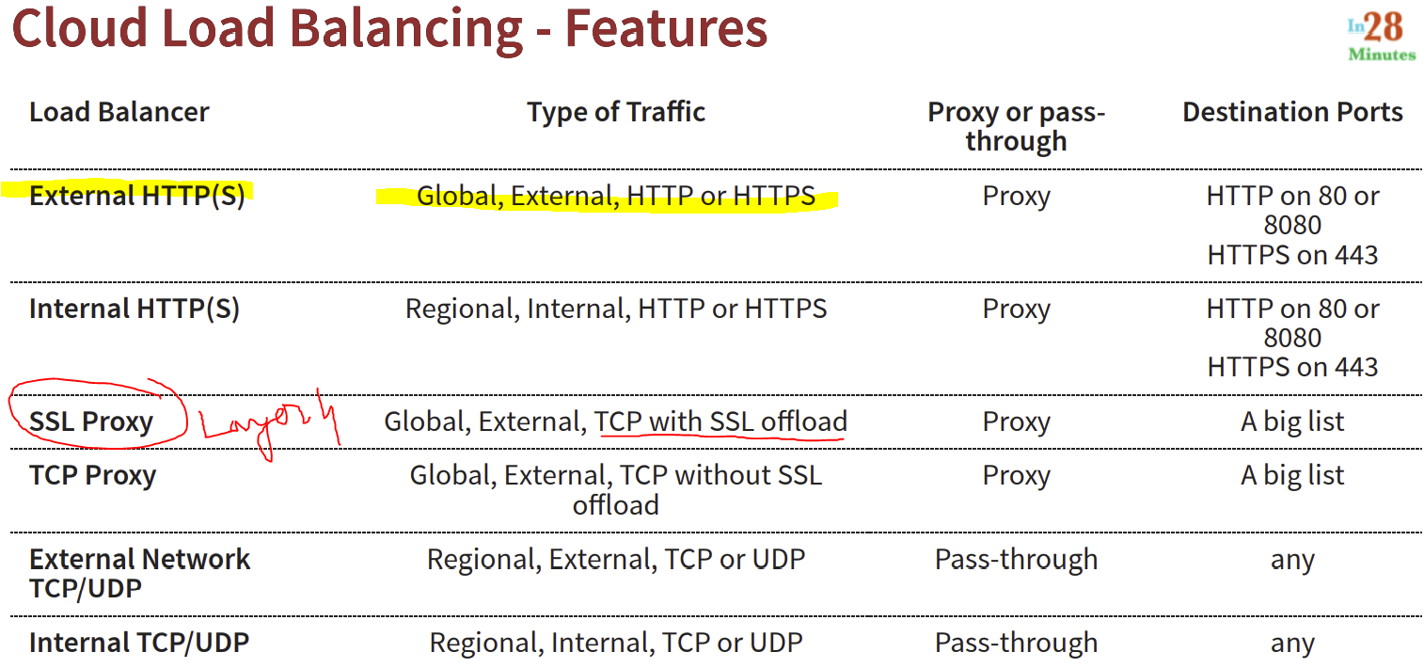

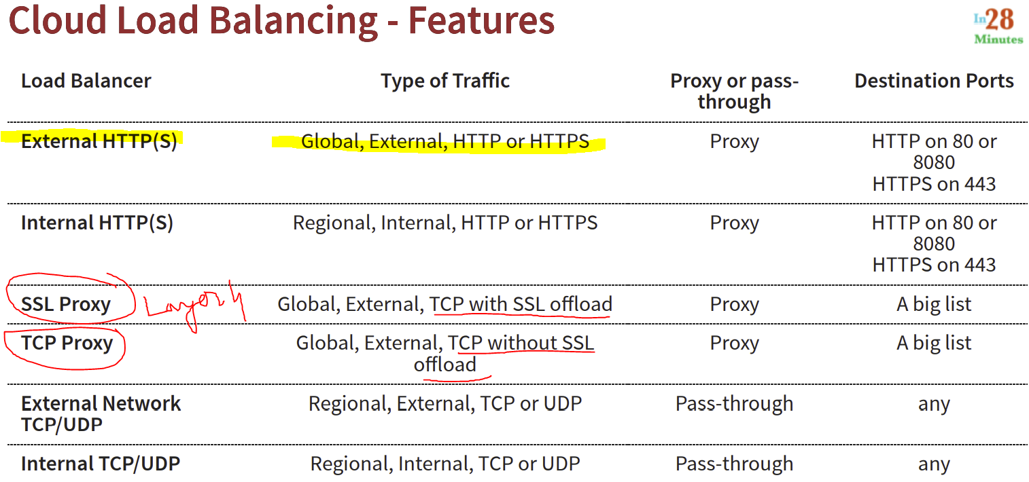

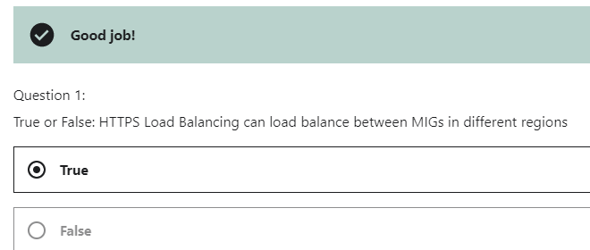

**\*\*\*\*\*\*\*\*\*\*\*\*\*\*\*\*\*\*\*\*Compute Engine & Load Balancing FOR ARCHITECTS\*\*\*\*\*\*\*\*\*\*\*\*\*\*\*\*\*\*\*\***

**It is not sufficient to get things working. We want more!**

* Build Resiliency
* Increase Availability
* Increase Scalability
* Improve Performance
* Improve Security
* Lower Costs and .....

High Availability for Compute Engine & Load Balancing

**Highly Available Architecture:**

* Multiple Regional Instance Groups for each Microservice
* Distribute Load using a Global HTTPS Load Balancing
* Configure **Health Checks** for Instance Group and Load Balancing
* Enable Live Migration for VM instances

Advantages:

* **Instances distributed across regions**.

Even if a region is down, your app is available

* Global Load Balancing is highly available.
* Health checks ensure auto healing.

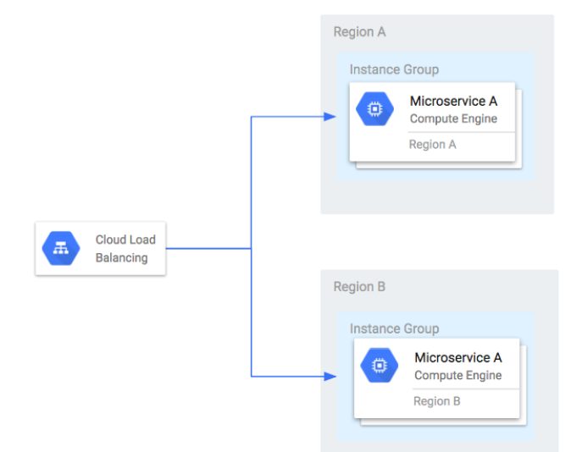

Home is a IP

Window /door is a port

Main door is webserver

Window – network ports / ssh

IP system has many services and each services has port .

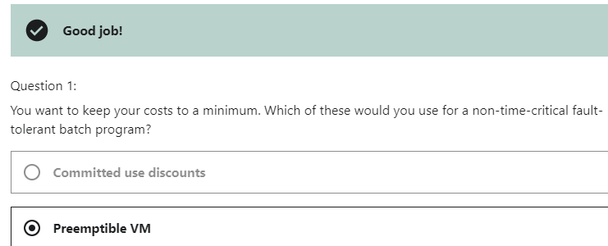

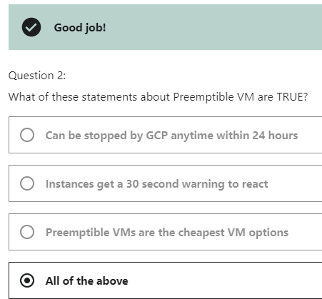

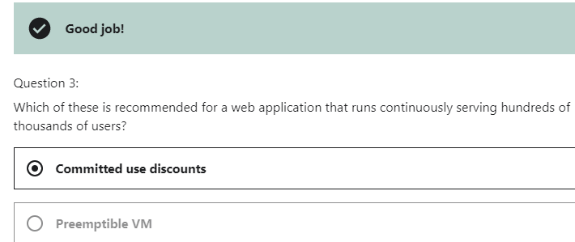

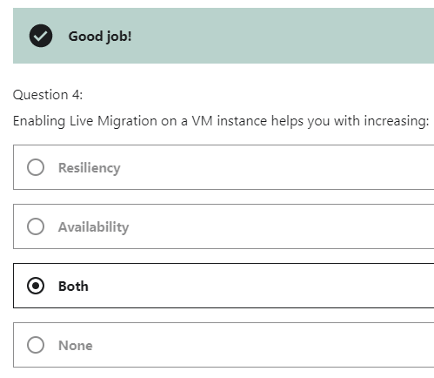



Gcloud init🡪

